Safeguarding Report 11th November 2025

There has been one safeguarding incident reported to myself and this was reported to Winchester and followed up and no further action was needed.

The Safeguarding Action Plan is attached and the following points need to be addressed.
Actions Points from Mandatory Requirements –
- Which safeguarding policy has the PCC approved?

As a PCC we are happy to continue to follow ‘Promoting a Safer Church’ and accept the Policy statement attached. Please note the Policy has not been renewed by National church since last year.

If yes new statement to be signed and dated by the Rector. After the meeting a signed copy will be given to each church to display on notice boards.

- The action plan needs to be accepted by the PCC as being the current situation.
Once accepted the date will be updated and the section will turn green.

- The Policy needs to be signed and re issued, no changes have been made since last signing in 2023.

- The Social Media Statement Policy has been updated by the Diocese, therefore our statement needs to be updated and accepted by the PCC. The old and new policy are attached.

- Known Offenders – are the PCC happy that the Incumbent and Parish Safeguarding Officer (PSO) are aware that Known offenders, and others who may pose a risk to children or vulnerable adults, must be effectively managed and monitored in consultation with the Diocesan Safeguarding Adviser.

I can confirm as PSO I am aware of the need for this. Rev Alex as Incumbent is also aware.
- Data Protection & Retention
I can confirm as PSO that all records comply with GDPR and that records are being retained in accordance with the Church of England guidance.
- Clergy Vacancy

The question asked is as follows with the statement from Key Roles and Responsibilities of Church Office Holders and Bodies Practice Guidance (2017)

If in this situation as PSO we would follow this measure.

Has the PCC discussed the secure storage of safeguarding records during a clergy vacancy?

"During an interregnum the PCC must, working with the churchwardens, ensure that all information about safeguarding matters is securely stored before passing the information on to the new incumbent. The departing incumbent must give the safeguarding information to the parish safeguarding officer who can pass the information on to the new incumbent when he/she takes up his new role."
- Churchwardens have read and are aware of the Churchwardens responsibilities.

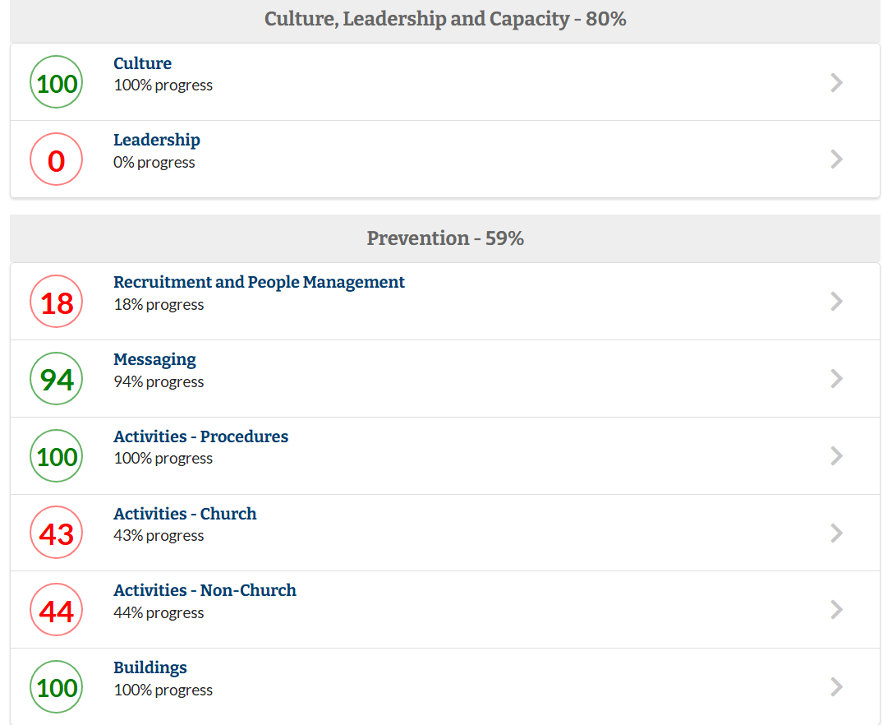
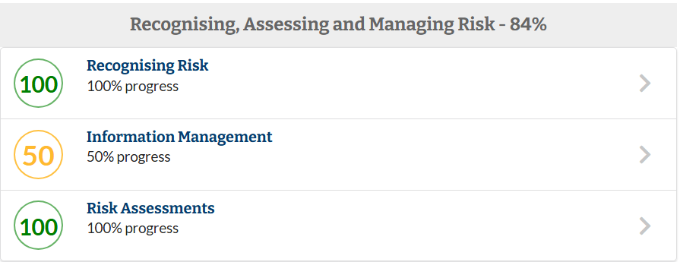
Our Current Safeguarding Standards position – screen grabs of the various sections are as follows with actions below which will help us move forward to a better position, although further work will be needed.
This is respect of Church Activities and until they are updated will not change
This is respect of Non - Church Activities and until they are updated will not change
Worksheet 1B needs to be discussed by the PCC
This is respect of Church Activities and until they are updated will not change
By answering Action point 6 & 7 this will go to 100%
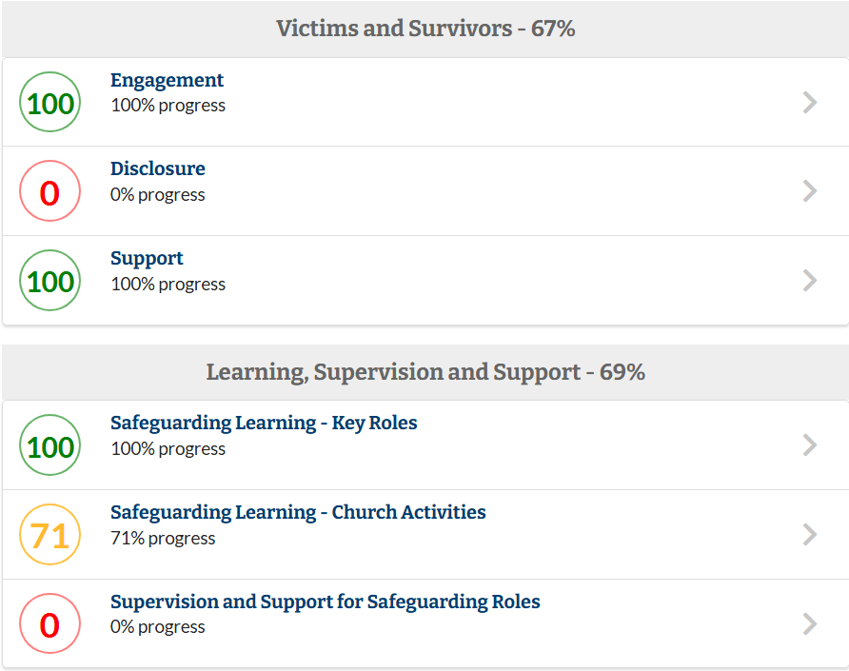
Worksheet 5A needs to be discussed by the PCC
Full team names are required to check training.
Worksheet 4A needs to be discussed by the PCC

Judith Appleby
6/11/25

